Network Key: 15c0415b5

1. Create Custom Adapter

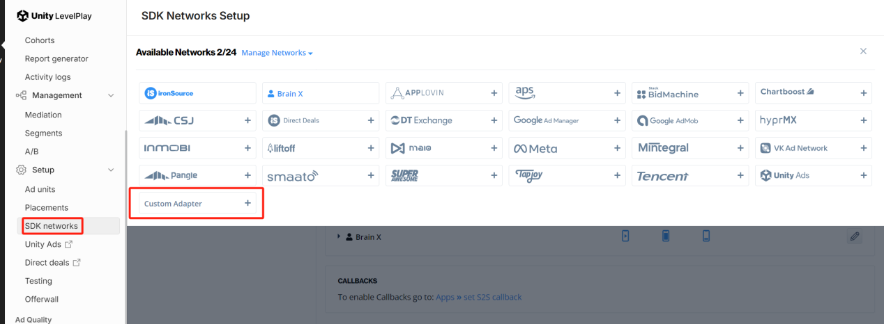

1. Enter Network Key

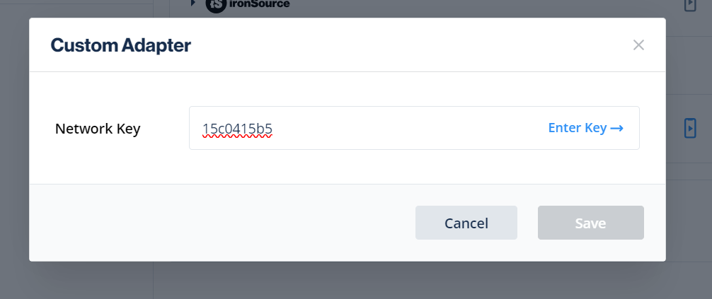

1. Enter app id and placement id

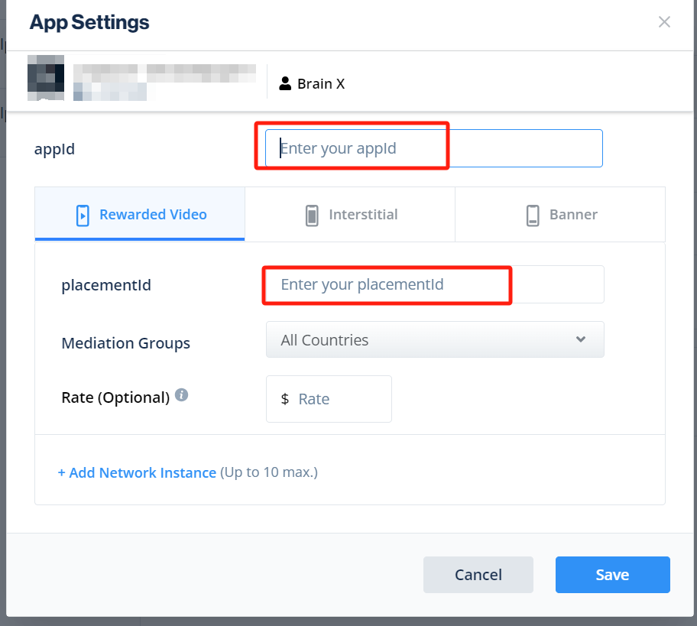

Notice：SDK Proguard rules：  
     -keep class com.td.\*\* { \*; }  
    -keepclassmembers class com.td.\*\* {  
        @com.td.\* public \*;  
    }